Question 2:

To run jar command: hadoop jar Assignment_3.3-Assignment_3.3.jar Question_2.TotalUnit /user/acadgild/hadoop/television.txt /user/acadgild/hadoop/TotalUnitOutput

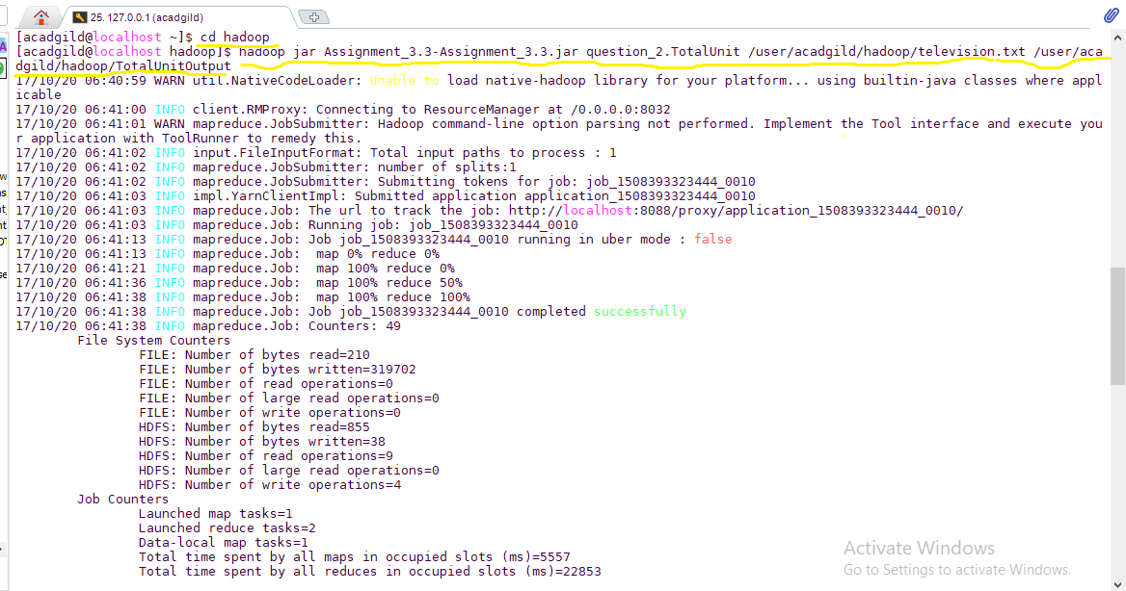

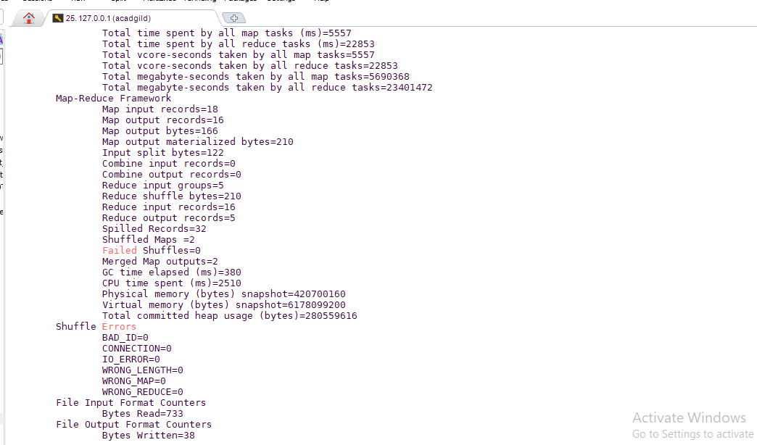

Output

